***MAKE A SIMPLE BRICK COMPOST BIN***

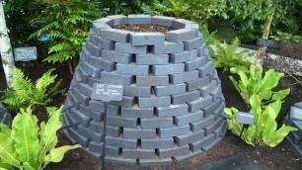 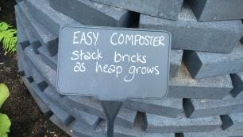 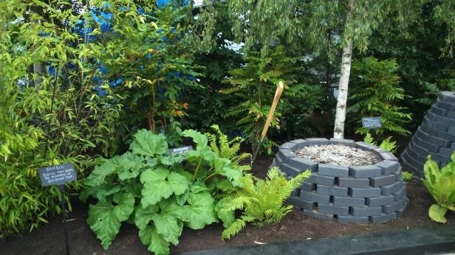

This compost bin is stylish and easy – designed to grow over time

If there’s no room for a traditional compost bin or the idea of a plastic bin is unpalatable, Juliet offers an alternative in this brick circular compost bin. If you have spare bricks lying around or can get some through a recycling site like Freecycle, this could be a cost effective way to start composting. Best of all, its temporary nature means it can be relocated easily once the compost is ready to use.